EXPERIMENT 6
Pay Roll Processing Using Zoho One (SaaS)
Aim
To develop a payroll processing system using Zoho One (Software as a Service – SaaS) to maintain employee details, calculate salaries, manage deductions, and generate payslips efficiently
Procedure
- Sign in to Zoho One: Open the Zoho One website and log in using valid credentials.
- Open the payroll application: Access the appropriate Zoho payroll application available for your organization or region.
- Add employee details: Enter employee ID, name, department, designation, and basic salary.
- Enter salary components: Define allowances such as HRA and other applicable benefits.
- Calculate gross salary: Add basic salary and allowances.
Gross Salary = Basic Salary + Allowances
- Calculate deductions: Record applicable deductions, such as provident fund, professional tax, and other authorized deductions.
- Calculate net salary: Calculate the final salary after deductions.
Net Salary = Gross Salary − Total Deductions
- Process payroll: Select the relevant payroll period, verify employee attendance and salary details, and process payroll.
- Generate payslips: Generate payslips containing employee details, earnings, deductions, and net salary.
- Generate reports: View or export payroll reports for record-keeping and accounting purposes.

Implementation Input:
n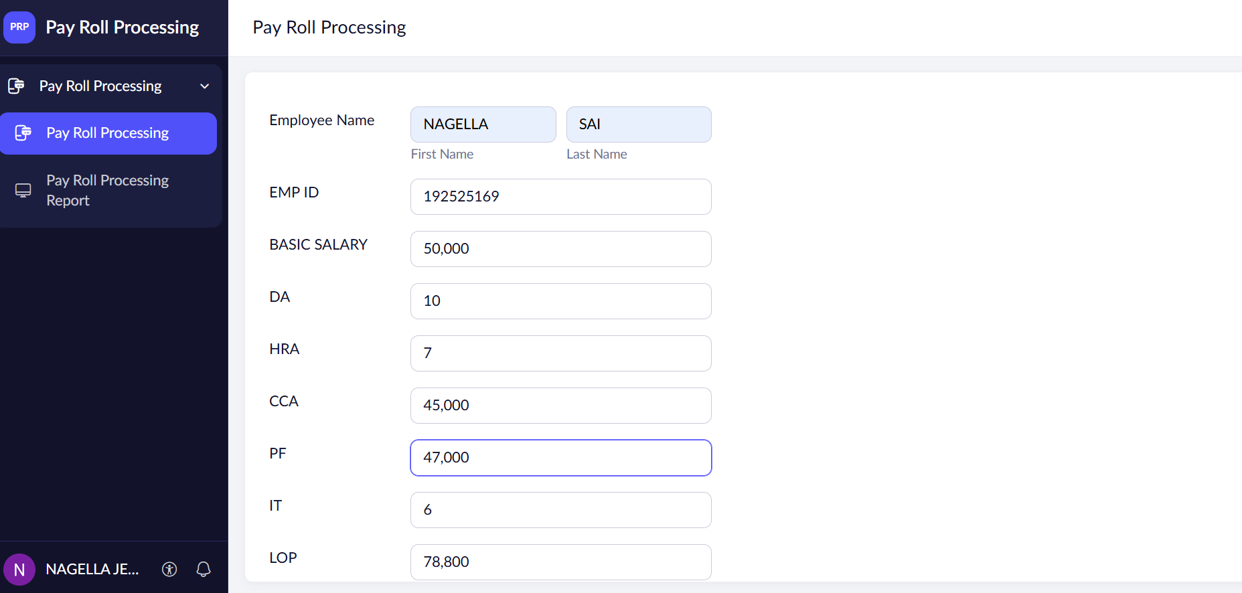
Output:
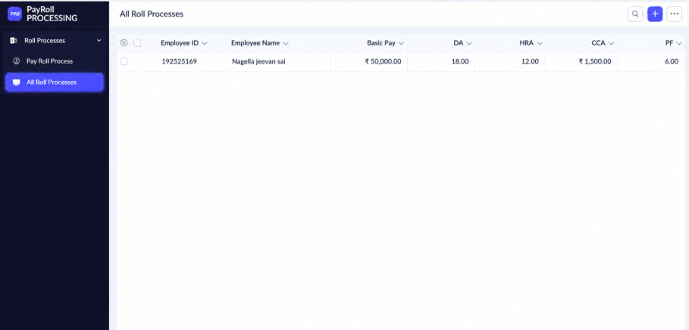

Result
Thus, the payroll processing system using Zoho One (SaaS) was studied. Employee details, salary calculations, deductions, net salaries, and payslips can be managed efficiently through an appropriate Zoho payroll application.

